(automatic translation)

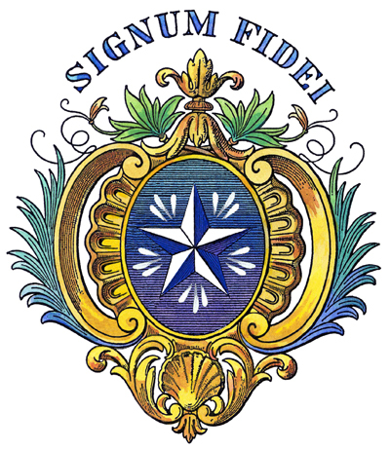***Live Jesus in our hearts! Forever!***

* ***Signum Fidei***: Sign of Faith

**"It is necessary that the school goes well**", Saint John Baptist de La Salle.

e-mail: [nsukulapie@yahoo.fr](mailto:nsukulapie@yahoo.fr)

**BROTHERS OF THE CHRISTIAN SCHOOLS**

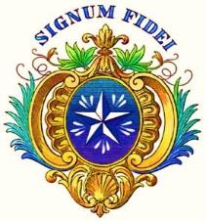

**The contribution of twelve virtues of a good student and a good parent to the development of education and instruction**

(Parents' handbook)

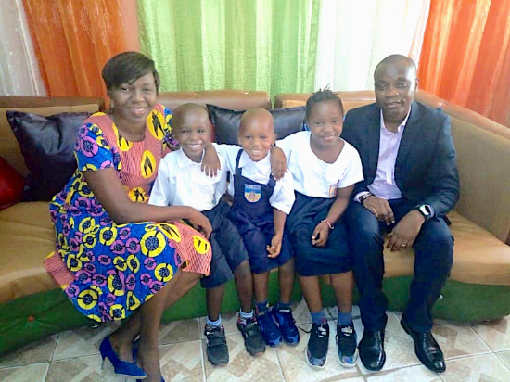

Kinshasa, DRC

© 2020

**NSUKULA BAVINGIDI** (**Brother Pie**)

Brother of the Christian Schools and Researcher in Education

at the National Pedagogical University, UPN/CREDE



"...make every effort to combine your **faith** with **virtue**, your **virtue** with **science...**"

(2 P 1:5-7)

**Table of Contents**

**Foreword** 2

**Abstract** 4

**Keywords** 4

**Introduction** 4

**1. Theoretical framework** 6

**1.1. Definition of concepts** 6

1.1.1. Vertu 6

1.1.2. Development 6

1.1.3. Education and Instruction 6

1.1.4. Schools of the Brothers 7

**1.2. Presentation of the environment** 8

**2. Methodological framework** 8

**3. The virtues of the student and the parent** 8

**I. The Twelve Virtues of a Good Student** 9

0. Introduction 10

**II. The Twelve Virtues of a Good Parent** 11

0. Introduction........................................................................12

1. Responsibility 14

2. Vigilance 15

3. Listening 16

4. Affection 17

5. Firmness 18

6. Tenderness 19

7. Self-sacrifice 20

8. Setting an example 21

9. Insight 22

10. Patience 23

11. Humility 24

12. Piety 25

**Conclusion** 26

**Bibliographical references** 28

**Annexes** 29

**Foreword**

Throughout the world, it is recommended that the rising youth be well supervised so that they will be useful in the future. In order to achieve this overriding objective, education and instruction must be well guaranteed. But who are the main actors?

In the first place, the parent who, as a progenitor, is called upon to follow the child's development into adulthood. This process is completed by the teacher at the school level.

As the student grows, he or she will need to know that the focus is on the student's well-being.

In view of his principal mission as educator, Brother Provincial Visitor, Nsukula Bavingidi Pie, also considered it opportune to place special emphasis on the contribution of the student in the development of education and instruction. For, as he points out in his booklet entitled: ***The contribution of the twelve virtues of a good pupil and a good parent in the development of education and instruction,*** "to educate is to bring out, to bring to light all the richness, all the beauty, all the powers of life which the child conceals in his soul and in his heart".

**Discipline**, **docility**, **listening, respect**, **punctuality**, **honesty, determination**, **application**, **emulation, mutual aid**, **humility** and **recognition** are the twelve virtues that the student must possess.

This raises questions about their impact on a child's life. This virtue (discipline) being the keystone of all educational activity, it brings order, work and success. In these times, discipline sometimes seems like a heavy burden for a student, but later on it can serve as a solid support for his or her development. It is then that the child will realize the impact of this virtue on his or her life.

At present, and particularly in the Democratic Republic of Congo, public opinion, all categories and tendencies combined, complains of the often unhealthy behaviour that characterises the rising youth. In order to remedy this situation, strict discipline is required. As time goes by, the child will be able to be docile and attentive. *Ipso facto,* in the classroom, he will be attentive to teaching.

For all these twelve virtues that the child must possess, the parent has a great deal of responsibility for their application, given his or her position as primary caregiver.

Being a parent and having children is not a coincidence. It is a blessing, a grace and a heavy responsibility, as Brother Visitor points out in his brochure. Moreover, the family environment plays a capital role in the development of the child. Hence its twelve virtues: **responsibility**, **vigilance**, **attentiveness**, **affection, firmness, tenderness**, **self-denial**, **exemplarity**, **insight, patience**, **humility** and **piety**.

As you can see, the twelve virtues of a good student and a good parent discussed in this booklet promote a child's success in all aspects of life. They contribute to the smooth running of the school.

Veron Kongo

Journalist and Assanetian

**Abstract**

*The development of education and instruction requires that each educational actor, namely parents, pupil and teacher, take an active part in educational action. However, in thinking about the profile that each actor should have, we have perceived a pressing need to have virtuous people for the education and instruction of children. The virtues of each actor, as developed in this booklet, will help each one, for his or her part, to carry out his or her mission wisely for the good of children and society.*

**Key words:** *Virtue, Development (of education and instruction), Education and Instruction, Brothers' Schools.*

**Introduction**

To educate is to bring out, to highlight, in full light, all the riches, all the beauties, all the powers of life that the child conceals in his soul and in his heart.

Education of the will is certainly the most important. It is the will, indeed, that constitutes man. It governs his whole being, it commands our mind as well as our body, makes us move from rest to action and from action to rest, develops virtues and vices.

Virtues are values, indispensable in the daily life of a people. The German philosopher, cultural critic, composer, poet, philologist and intellectual Friedrich Nietzsche (1844-1900) said: "No people could live without first setting values", J. Casevecchie (2009). In this regard, we can reveal certain virtues that can help students and parents to be good students and good parents, including **discipline**, **docility**, **listening, respect**, **punctuality, honesty**, **determination, application**, **emulation, mutual aid**, **humility** and **recognition**. Those of a good parent are : **Responsibility**, **vigilance**, **listening**, **affection**, **firmness, tenderness**, **self-denial**, **exemplary**, **insight, patience, humility** and **piety**.

John Baptist de La Salle, quoted by Brother Agathon, the fifth Superior General of the Brothers of the Christian Schools (1834), sums up the virtues of a good teacher in twelve words: **Gravity**, **silence**, **humility, prudence**, **wisdom, patience, restraint**, **gentleness, zeal**, **vigilance**, **piety** and **generosity**.

*The contribution of the Twelve Virtues of a good pupil and a good parent in the development of education and instruction* is therefore an indispensable complement to the *Twelve Virtues of a good Teacher*. Motivated by the evidence that the triad of virtuous parents, virtuous pupils and virtuous teachers leads to the success of a child's integral education, this work constitutes an indispensable tool to help parents and pupils to be virtuous.

**1. Theoretical framework**

**1.1. Definition of concepts**

**1.1.1. Vertu**

Vertu comes from the Latin *virtus,* which means "constant disposition to do good and avoid evil"; it is also a "particular quality", *Le Petit Larousse 2003*.

However, when we talk about the *virtues of a good student and a good parent,* we are referring to the good qualities that the student and his or her parents must have in order to help the child succeed not only in school but in life.

**1.1.2. Development**

Synonymous with flight, is the stimulus that boosts education and instruction, that is to say, helps them to move forward, to be successful.

**1.1.3. Education and Instruction**

**Education** can be defined as "a set of actions taken by parents to ensure the development of their children in terms of their physical and mental health, but also in terms of their emotional and social, moral and spiritual, intellectual and cultural development", P. Dembour (2008).

**Instruction** and **education** should not be confused. F. Macaire & P. Raymond (1964) explain: "It is said of a **man that** he is **educated** when he has been educated and has **acquired a** fairly extensive **knowledge**". While when **someone** is said to be **well-educated**, the authors add, it is because "in addition to **education,** he has received **moral** and **social training**".

In short, the **instruction** focuses on the **intellectual formation of the** child. This is part of education. **Education, on the** other hand, deals with the **integral formation of the** child: intelligence, heart, will.

**1.1.4. Schools of the Brothers**

The schools of the Brothers, called "Lasallian Schools", are institutions run by the Congregation of the Brothers of the Christian Schools. They were founded in 1680 by John Baptist de La Salle, a French priest. These religious establishments were created in France to alleviate the situation of abandonment and distress to which the children of the artisans and poor of 17th century French society were subjected. John Baptist de La Salle had therefore understood that "education is a right for all, including the poor".

Broadly speaking, the purpose of the Congregation of the Brothers of the Christian Schools is "to ensure a human and Christian education for young people, especially the poor [...]", R. Schieler (2015).

**1.2. Presentation of the environment**

Our research milieu is the Lasallian milieu, an educational milieu made up of the teachers, parents and students of the Brothers' schools.

**2. Methodological framework**

To teach parents and students how to become virtuous people, we organized seminars, training sessions, and presentations. First, we targeted about 20 schools in Kinshasa and the interior of the country. During these sessions, effigies containing these virtues were distributed to the participants. Also, the invitation was extended to the various school management staff to engrave them on the wall.

**3. The virtues of the student and the parent**

Virtues are of great importance in the education and instruction of children. In order to bring an innovation to the writings of J.B. de La Salle (1706) on *The Twelve Virtues of a Good Teacher*, we have had to list twelve virtues for a good pupil and twelve others for a good parent, P. Nsukula (2018). These virtues are the following:

**I.**

**The Twelve Virtues**

**good student**



**0. Introduction**

In the context of the new education, the child should not be seen as a vessel to be filled but as a spring to be tapped. This is why Hoffer suggests this:

*The teacher must not take the place of the child in deciding for him or her or impose attitudes or gestures that are inwardly disowned [...]. The child must remain the main agent of his or her training, because lasting progress comes only from an action accepted or consented to by the child,* P. Dembour (2008).

Indeed, for a child to be truly good and honest, he must possess the following twelve virtues: **Discipline**, **docility**, **listening, respect**, **punctuality**, **honesty, determination**, **application**, **emulation, mutual aid**, **humility** and **recognition**.

* *Confer* ***The Twelve Virtues of a Good Student*** (Student Handbook)

J0105250

**II.**

**The Twelve Virtues**

**good parent**



**0. Introduction**

It is good for man and woman to be virtuous people. In marriage, a divine institution, man and woman must love each other every day of their lives, in happiness and in trials. They must live faithfulness until death do them part (Liturgy of the Sacrament of Marriage).

The Holy Scriptures tell us that the righteous man is one who loves his wife as himself (Eph 5:33); he protects her and makes her happy. In short, a righteous man will always seek the good of his wife and his family.

As for the virtuous woman, she is a precious pearl. She is the pride, joy, and glory of her husband (Prov 12:4). (Prov 12:4) She is even more valuable than pearls. Her husband has a trusting heart; his house lacks nothing. (Proverbs 31:10-29) She does good to her husband every day of her life. (Prov 31:10-29) In short, a virtuous woman is a wise woman; she builds her house.

Indeed, **being a parent** and **having children is not a matter** of chance. It is a **blessing, a grace**, and **a heavy responsibility.** (Jb 42:12-16; Gen 15:1-5; Ps 128:1-6; Eph 6:4) It is a **blessing, a grace,** and a **heavy responsibility.**

Although **parenthood** (fatherhood and motherhood) is a grace, it is **learned** because no one is born a father or a mother. P. Dembour (2008) said: "Raising a child is one of the most demanding and hardest jobs in the world ...".

(Ps 127:3) **Children** are **a treasure**. (Ps 127:3) They are the essence of what parents are all about. (Ps 127:3) They are an important reason for providing children with a quality education that will guarantee them a better future.

Confucius (c. 551-479 B.C.), a Chinese educator and philosopher-writer, agrees when he says: "If **your plan** is for **one year**, **plant rice**; if your plan is for **ten years, plant trees**; if your plan is for a **hundred years**, **educate the children**".

The **family environment** plays a **crucial role** in child development. Don Bosco (1850) says: "[...] Every home is a school of Life and Love".

Indeed, for a parent to be truly at the top of his or her game and have a positive influence on the future of his or her children, he or she must possess the following twelve virtues: **Responsibility**, **vigilance**, **listening, affection**, **firmness, tenderness**, **self-denial**, **exemplary**, **insight, patience, humility** and **piety**.



**1. Responsibility**

This virtue is **the pedestal** on which the other virtues are built. Being a parent is not enough. It is still necessary to be a responsible parent.

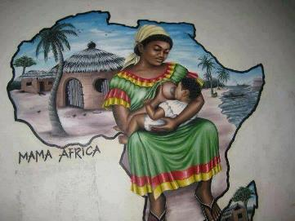

A **responsible parent cares** about **their family**. (Deut 4:9; Eph 6:4) He raises his children by correcting and instructing them.

A responsible parent properly fulfils his duties as a parent: he takes care of his family, watches over the human and religious education of his children, controls their development at school, pays their school fees, clothes them, feeds them, etc.

Parents are primarily responsible for their children. (Prov 22:6; Joel 1:1-3; Eph 6:4) They have an obligation to care for them with dignity.

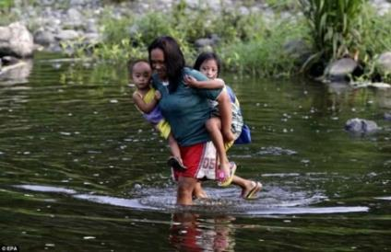**Responsibility in** the **family** is a **good school**. It teaches good leadership. (1 Timothy 3:1-5) The person who does not know how to run his or her own home will find it difficult to lead his or her fellow men.

It is important to know that at the creation of the world, God entrusted our first parents (Adam and Eve) with the responsibility of continuing his work of creation (Gen 1:26-30). (Genesis 1:26-30) Today, that responsibility rests with us.

1. **Vigilance**

Vigilance: from the Latin *vigilantia*, habit of watching. A **good parent** is like a **watchman**. He watches over his family in the manner of Christ, the Good Shepherd (Jn 10:7-16), as the apple of his eye (Zech 2:8), as an eagle watches over its young (Deut 32:10-11), or as a hen gathers its chicks or brood under its wings (Matt 23:37; Lk 13:34).



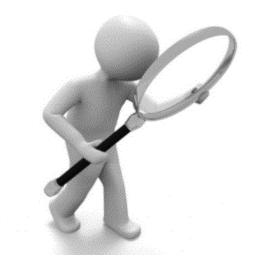A vigilant parent needs to know who their children are dating, and who they are around. He or she must follow the children's progress at school, monitor their use of Information and Communication Technologies (ICTs), etc.

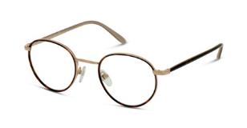In short, the vigilance of parents in this pluralistic world must encourage them to watch over their children's development in all areas of life.

**3. Listening**

Synonymous with **hearing** (lat. *intendere, to* apply one's mind), **perceiving through hearing, listening** (lat. *auscultare),* it is "to lend an ear to; to apply oneself to hearing; to **be attentive to**", *Le Petit Larousse 2003*.

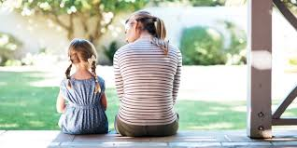**A parent needs to be able to listen to** his/her **partner** and **children**. Good things can also come out of children's mouths. What God has hidden from the wise and intelligent (learned), he reveals to children (Matt 11:25; Luke 10:21). (Matthew 11:25; Luke 10:21) How many parents have not had to make serious mistakes because they did not listen?

In the family, **listening** encourages **dialogue**, and **dialogue** brings **peace** and **harmony**.

**4. Affection**

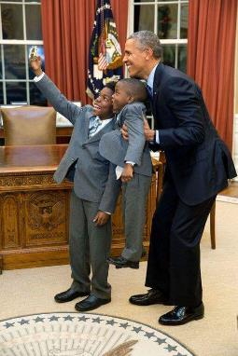From the Latin *affectio*, affection is an "attachment that one feels for someone; tenderness".

Act No. 87-010 of 1 August 1987 on the *Family Code*, article 459, stipulates: "Spouses owe each other **fidelity**, **respect**, **consideration** and **affection.**

(Genesis 2:24; Matthew 19:5; Mark 10:7-8; Ephesians 5:31) .

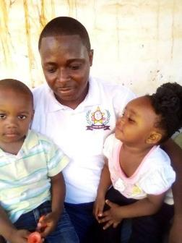In the family, when **parents love each other,** they set an **example for** their **children**. In other words, by living their conjugal union in perfect harmony, parents teach their children to do the same when they grow up.

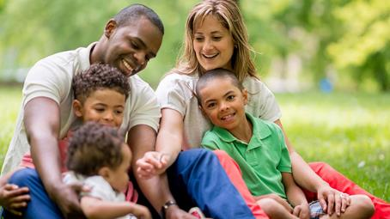

It is this love that unites parents, and of which we are the fruit, that allows us to grow in trust; trust that is necessary for a balanced and generous life, for the fulfilment of our human vocation.

**5. Firmness**

From the Latin *firmitas*, firmness is an "attitude of rigor excluding weakness towards others; authority".

A firm parent is bossy. It is the opposite of a laissez-faire or permissive parent.

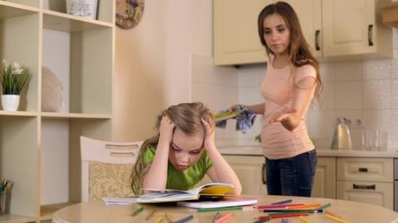Parents must be firm with their children. It is that firmness that will ensure that they will have children who are sufficiently educated.

Parents have an obligation to make way for their children. In this regard, the Scriptures say: "Instruct the child according to the way he must go; and when he is old he will not turn away from it.

The precepts, teaching and warnings of correction on the part of parents are for their children the lamp, the light and the path of life (Pr 6:20-23). (Prov 13:24; 29:15,17) **Firmness** comes through **love** and **correction. (Prov 13:24; 29:15,17) Do we not** say, "Who loves well, chastises well" (*Qui bene amat, bene castigat)*? (Qui bene amat, bene castigat) Correction must be individual, in proportion to the age of the child and the offence committed. (Prov 3:12; Heb 12:6-7) The Scriptures remind us that as much as God chastises the one he loves, so much a parent will do it for the child he cherishes.

**6. Tenderness**

To have **tenderness** towards one's spouse, towards one's children, is **a sign of love**. The parents' tenderness will make the children see in them people capable of loving, understanding and forgiving them.

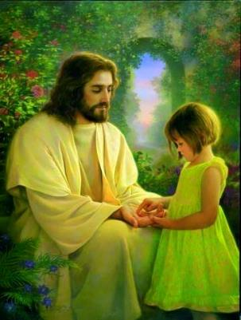Tenderness must also manifest itself through language. The words that come out of parents' mouths must be good. Dear **parents**, for the sake **of your children,** "let **no evil word come** out of your mouth, but if there be any **good word,** let it serve for edification and impart grace to those who hear it." (Eph 4:29) This is another commandment from the Holy Scriptures.

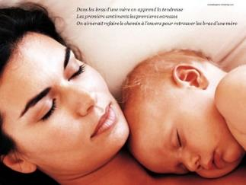(1 Thess 2:7-8, 11) Parents need to show their love and gentleness to their children. (1 Thess 2:7-8, 11) This human warmth begins in the womb at birth and should continue into adulthood. (Isaiah 49:15; Psalm 103:13) Children, however old they may be, will always be "children" of their parents.

**7. Self-sacrifice**

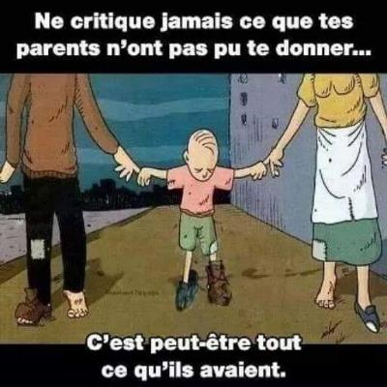From the Latin *abnegatio* (i.e. to refuse), abnegation is synonymous with sacrifice, renunciation.

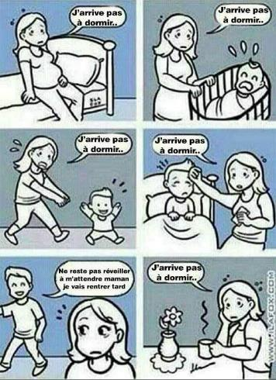**Raising** children does not come without a spirit of **sacrifice**. For the good of children, parents must have selfless love, a spirit of sacrifice and devotion. This will sometimes lead them to forget themselves for the benefit of their children.

Christ's love for us sinners is a tangible sign of sacrifice. It is kenosis (stripping): Having the condition of God, Christ did not retain the rank that equaled him to God. He took our condition of man, except for sin, and accepted the death of the cross (Phil 2:5-11).

**8. Setting an example**

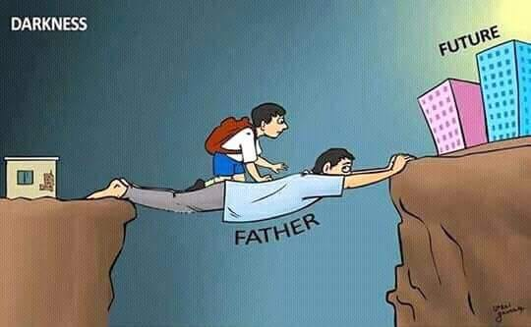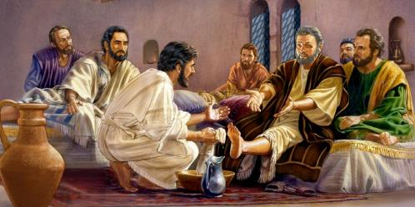Macaire & P. Raymond (1964) point out that **education** is **done** much more **by example than by word of mouth. In** other words, the testimony of life is better than words; or again, our world today has more need of people who live what they say. **Parents** are supposed to be role **models** because children easily imitate what adults do. The proverb "Like father, like son" or "Like mother, like daughter" confirms this. In the same vein, speaking of exemplarity as a moral virtue that parents must have, P. Dembour (2008) says: "Fathers and mothers must set an example or risk discrediting themselves.

**The example,** as is often said, **comes from above**. By washing the feet of his disciples, Jesus Christ, Lord and Teacher, gives us a good example to follow (Jn 13:1-17); likewise the apostle Paul, when he said to the Corinthians: "Be imitators of me, even as I myself am of Christ" (1 Cor 11:1).

**9. Insight**

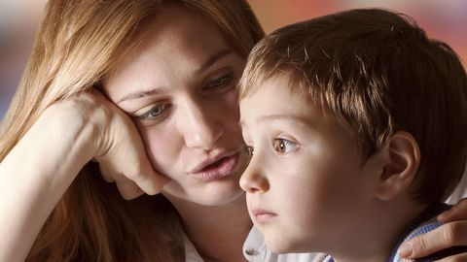Synonymous with **clairvoyance**, a perceptive parent is one who knows how to detect and anticipate what is in the child; in other words, he or she must know how to read the child's face.

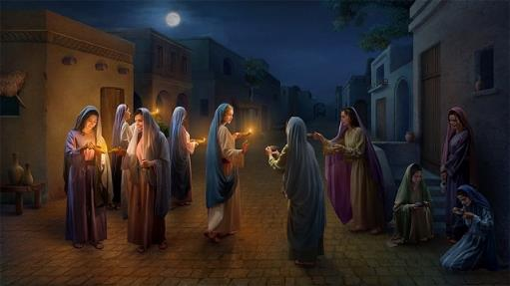 With this virtue, the parent will have the **ability to find out** if the child is telling the truth or not, if the child is healthy or not. In short, **a parent's view of** his children must always be one of **attentiveness** and **discernment**.

Following the example of five wise virgins (Mt 25:1-13), a discerning parent must be farsighted. He must make good use of his wages (from the Latin *salarium,* derived from *sal,* salt) to provide for himself and his family. The next day, as they say, is prepared today.

**10. Patience**

From the Latin *patientia*, patience is "the ability to bear with constancy or resignation the evils and inconveniences of existence", *Le Petit Larousse 2003*.

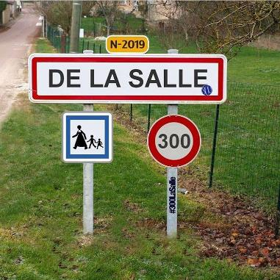

Being a parent also means having patience as a virtue. **Parents** should **avoid acting out of anger**.

When faced with certain situations, they are therefore invited to take a step back in order to avoid hasty and regrettable conclusions.

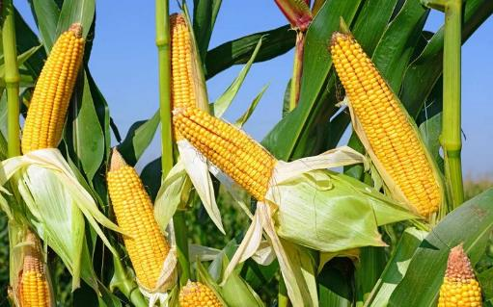 Educating children can take time before it produces the desired results. Parents need to be **patient**, as is **the farmer** who waits patiently for the fruit of the earth. (James 5:7) The parents must be patient**,** just as the **farmer** waits patiently for the fruit of the earth. Denis Sonet (1926-2015), a French Catholic priest, agrees with this when he says: "Do not pull on the grass so that it will grow faster! ».

**11. Humility**

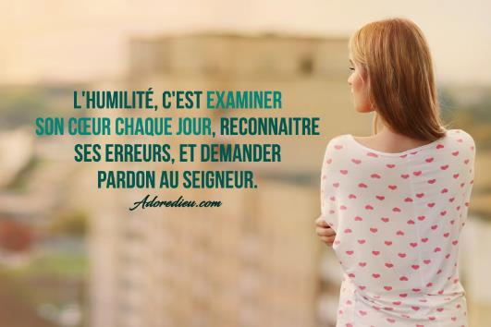It is a "state of mind, the attitude of someone who is humble". **Humility** is **not** a **sign of weakness**, **but** of **strength**. It is important for parents to have a sense of humility, to know how to apologize if they forget or make mistakes.

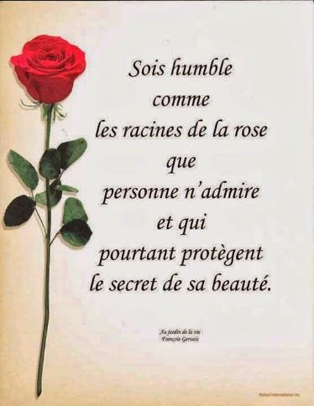Humility in marriage is not having pretensions or a taste for greatness; it is letting oneself be drawn to what is simple (Rom 12:16). (Rom 12:16) In other words, it is to recognize oneself as small in front of the other, to be able to make oneself one's servant (Mt 23:11; Phil 2:3). (Mt 23:11; Phil 2:3) The greater one is, the more one must humble oneself (Si 3:17-20).

The humility of parents will have a positive impact on the lives of their children, who will imitate them.

**12. Piety**

A **parent who prays** will set an **example for his or her family**. "Family that prays, family that lives," *said* Pope Pius XII.

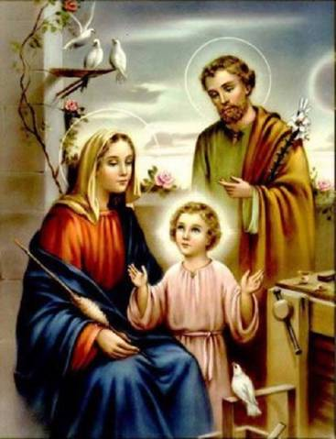

The **Holy Family of Nazareth** (Jesus, Mary, Joseph) is a **model of piety** par excellence. Joseph and Mary instilled their piety in Jesus from his childhood, taking him to places of worship, the Holy Bible reminds us, (Lk 2:22-52).

We conclude this chapter by saying that since the **family is the basic unit of society,** it has an interest in providing children with a good education. It is the family that has **the primary responsibility for the education of children**. R. Musomo (2014) points out that "parents are the first educators of those who owe their lives to them". And among the **missions of the family,** specifies the author, there are, for example: to **preach by example** and **to constitute the model to be followed or imitated**; to **lay the first steps of an education** that must be constituted by the other educational milieus.

**Conclusion**

Education, having as its primary objective the development of the child's personality, must call upon virtues. Section 2, article 14 of *Framework Act No.* 14/004 of *11 February 2014 on National Education* (From education to values) states: "National education incorporates human values, in particular moral, spiritual, ethical, cultural and civic values".

In the same vein, P. Dembour (2008) states: "Education is the result of parents' concern to transmit values, rules of life, behaviours, ideas... for the happiness of their children, in order to make them autonomous and responsible". To show that any parent can educate, the author goes further by saying:

*Education requires love, common sense and a certain intelligence of the heart that is within the reach of all parents. There is no need for diplomas and high intellectual capacities. All parents are capable of educating*.

When the main actors in education and instruction - parents, students and teachers - are virtuous persons, they will be able to carry out their mission wisely.

The twelve virtues of a good student and a good parent that we have studied in this booklet promote a child's success in all aspects of life. They contribute to the smooth running of the school. What is more valuable in the education and instruction of children than to have parents and virtuous teachers in their path? It is as Stephen King said: "Good teachers, like virtuous wives, are priceless pearls.

 Certainly, "educating one's children is a service to be rendered, a duty to be accomplished", P. Dembour (2008). A parent who educates his child well today educates generations, because the child who is well educated today will do the same for his children tomorrow.

*I,…………………………………… uh.****.. ...****I'm a parent and I want the best for my children and my whole family. I pledge to be good and virtuous. I will fight anti-values. I realize that the well-being of my family will depend on my sense of responsibility. I will faithfully follow what God recommends to me. I will avoid any act that may harm the life of my family.*

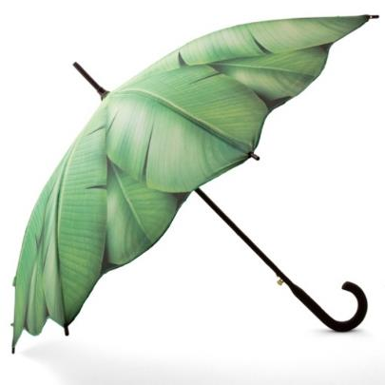*I will fulfill my duties as a parent in the fear of the Lord, with love and self-denial. I will be a role model for my family, following the example of the "Good Shepherd".*

**Bibliographical references**

* Agathon, F. (1834), *Les Douze Vertus d'un Bon Maître,* Avignon, Chez Seguin Aîné
* Casevecchie, J. (2009), *Une idée philosophique par jour,* France, Editions du Chêne
* Dembour, P. (2008), *Parents responsables! Ou comment conduire ses enfants sur le chemin de la vie*, France, Editions Mols
* Hurault, B et al (1998), *La Bible des Communautés Chrétiennes,* Kinshasa, Médiaspaul
* Act No. 87-010 of 1 August 1987 on the *Family Code of the Democratic Republic of the Congo,* Article 459
* *Framework Act No. 14/004 of 11 February 2014 on National Education*, Kinshasa.
* Macaire, F. & Raymond, P. (1964), *Notre Beau métier, Manuel de Pédagogie Appliquée, Seine,* Editions Saint-Paul
* Musomo, R. (2014), *Manuel de Pédagogie Générale, Sixième Année Pédagogique,* Kinshasa, Médiaspaul.
* Nsukula, P. (2018), *RELAF Newsletter No 28,* Abidjan, Christian Brothers
* Schieler, R. (2015), *Rule of the Brothers of the Christian Schools,* Rome.
* Second, L. (1910), *The Holy Bible (LSV)*, Solvus Lab
* *Le Petit Larousse 2003,* Paris, Larousse
* Don Bosco (1850), *The Strenna of Don Bosco,* Founder of the Salesian Congregation,<http://donboscocanada.org/strenna_2017/>
* Stephen King, <https://dicocitations.lemonde.fr/.../les-bons-professeurs-comme-les-...>

* Pictures and photos: *Google* & Brother Pie

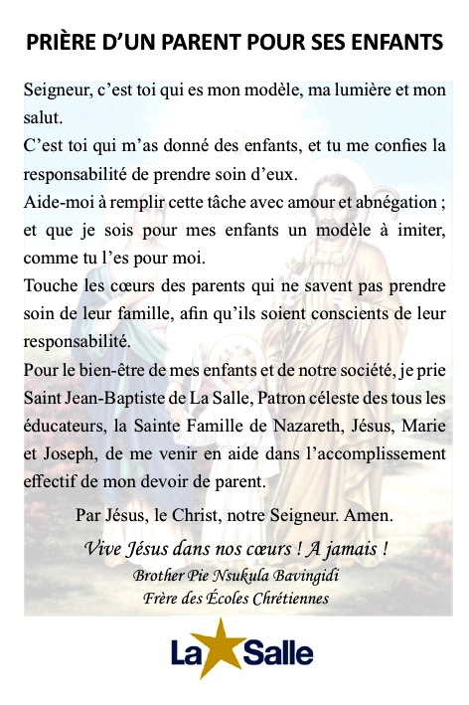**Appendix 1**

**Appendix 2**

**TEACHER'S PRAYER BEFORE SCHOOL**

Lord, it is you who are my strength and patience, my light and counsel; it is you who submit to me the hearts of the children you have entrusted to my care.

Don't leave me to myself for a moment. Give Me for my own conduct and that of my pupils, the spirit of wisdom and intelligence, the spirit of counsel and strength, the spirit of science and piety, the spirit of your holy fear, and an ardent zeal to procure your glory.

I unite my work to that of Jesus Christ, and I pray to the Blessed Virgin, Saint Joseph, the Guardian Angels, Saint John Baptist de La Salle, to protect me in the exercise of my work. Amen!

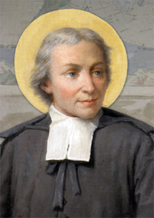

**Saint John Baptist de La Salle** (1651-1719)

Founder of the Congregation of the Brothers of the Christian Schools

Heavenly Patron of all Christian Educators

**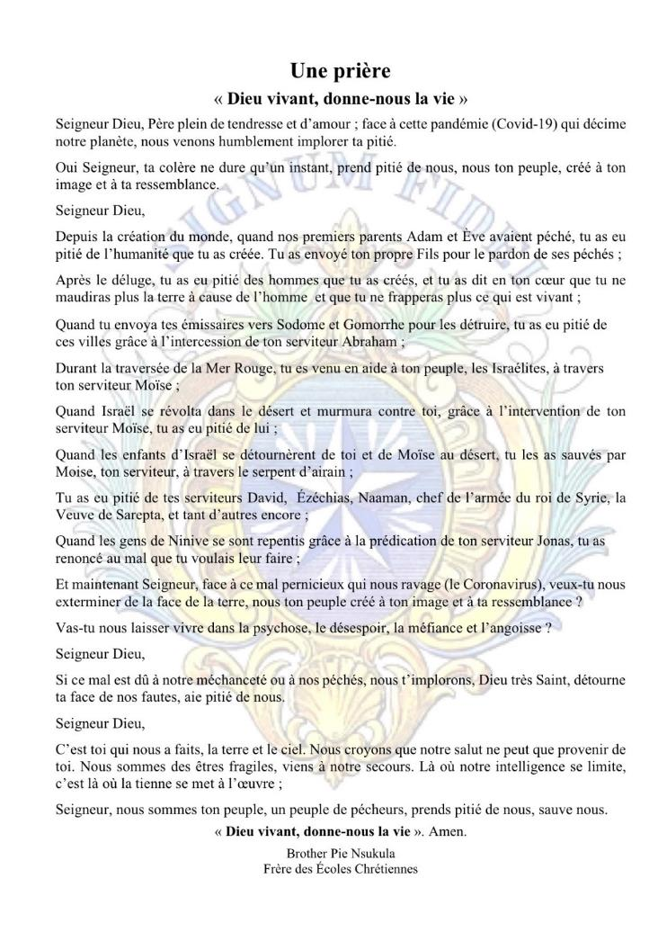   
Appendix 3**

**Appendix 4**



A souvenir text

**THE PLOUGHMAN AND HIS CHILDREN**

Work, work, work hard:

It is the fund that is least lacking.

A rich ploughman, sensing his impending death,

Made his children come, spoke to them without witnesses.

"Beware," he told them, "of selling the inheritance...

What our parents left us:

There's treasure hidden inside.

I don't know where; but a little courage

You'll find it. You'll get it.

Stir your field as soon as we've made the eye:

Dig, search, spade; leave no place

Where the hand does not pass back and forth. »

With the father dead, the sons return the field to you,

Within, beyond, everywhere: so much so that at the end of the year

He brought more.

Money, no hiding. But the father was wise

To show them, before he died,

That work is a treasure.

Jean de La Fontaine