(Automatic translation)
Live Jesus in our hearts! Forever!

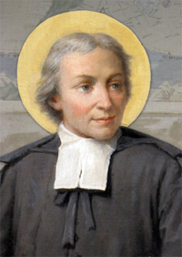

Saint John Baptist de La Salle (1651-1719)
Founder of the Congregation of the Brothers of the Christian Schools
Heavenly Patron of all Christian Educators

"It is necessary that the school goes well", Saint John Baptist de La Salle.

e-mail: nsukulapie@yahoo.fr

BROTHERS OF THE CHRISTIAN SCHOOLS

The Twelve Virtues of a Good Student
(Student handbook)
Kinshasa, DRC

© 2020

NSUKULA BAVINGIDI (Brother Pie)

Brother of the Christian Schools and Researcher in Education

"I'm a blessing to my students, and my students are a blessing to me".

Brother Pie

Introduction

To educate is to bring out, to highlight, in full light, all the riches, all the beauties, all the powers of life that the child conceals in his soul and in his heart.

Virtues are values, indispensable in the daily life of a people.

Virtue comes from the Latin virtus, which means "constant disposition to do good and avoid evil"; it is also a "particular quality", Le Petit Larousse 2003.

However, when we speak of the virtues of a good student, we are referring to the good qualities that the student should have, qualities that will help him to succeed not only in his schooling, but in his life. Thus, Hoffer suggests: "The child must remain the main agent of his or her education, because sustainable progress comes only from an accepted or consented action on his or her part", P. Dembour (2008).

For a child to be truly good and honest, he or she must possess the following twelve virtues: Discipline, docility, listening, respect, punctuality, honesty, determination, application, emulation, mutual aid, humility and gratitude.

1. Discipline

School discipline is "the totality of measures adopted to ensure order, work and morality at school .... It concerns the teacher as well as the student", R. Musomo (2014).
Discipline is the "keystone" of any educational activity. Success depends largely on it. Where there is discipline, there is order, work and success.

Discipline goes hand in hand with science (Pr 12:1): "He who loves discipline loves knowledge ..." B. Hurault et al (1998).

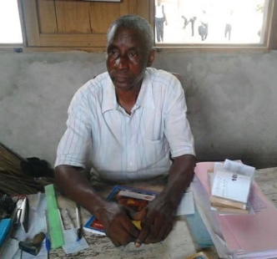
At times, discipline may seem like a heavy burden for a student, but later it serves as a solid support for his or her development in society. In this regard, the Scriptures say: "...no discipline in the present seems to be a cause of joy but of sorrow; but in the future it makes the fruit of righteousness peaceful ..." (Hebrews 12:11) .

At school, a disciplined student strictly follows the Internal Regulations (R.O.I.), as issued by the authorities.

2. Docility
This word comes from docere = to teach; docilis = willing to learn, who learns easily; docilitas = ability to learn easily.

Synonymous with obedience, the docility of a schoolboy is manifested by his simplicity towards all those involved in education. This pupil is as simple as a dove (Mt 10:16), and as docile as a lamb (Acts 8:32).
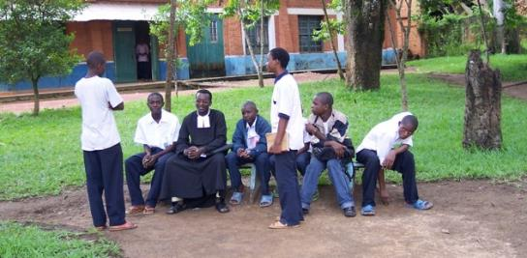

Considering himself in a learning process, in search of knowledge, the docile student will have a great openness to learn new knowledge.

3. Listening

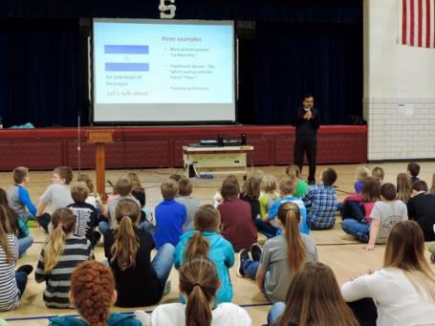
Listening is very important in every person's life. Children must listen to their parents. (Prov 1:8-9) "Listen, my son, to your father's instruction, and do not reject your mother's teaching .

A student who listens acquires truth, wisdom, instruction and understanding (Pr 23:22-23). (Pr 23:22-23) On the other hand, an inattentive ear will not learn enough. Listening is also knowing how to keep quiet. In the classroom, it will encourage a good student to be attentive to what is being taught.

4. Respect

Respect comes from the Latin, respectus. It is the "feeling that leads to treating someone, something with great respect, not to harm something", Le Petit Larousse 2003.

Similar to politeness, a respectful student is one who shows respect towards himself, his teachers, his fellow students, people of all races, all the goods present in the school, and also towards his environment.

Respect?
- I respect myself.
- I respect others: parent, teacher, student...
I am respected by others: by my parents, teachers, other students...
- I'm breathable...
- I respect laws, rules, customs...
- I respect ideas, words, values, institutions...
- I respect places, things...

(Exodus 20:12) He who honors his parents will see his sins forgiven; he will find joy in his children; his prayer will be answered; he will live a long life... (Exodus 3:3-16) He who honors his parents will see his sins forgiven; he will find joy in his children; his prayer will be answered; he will live a long life.

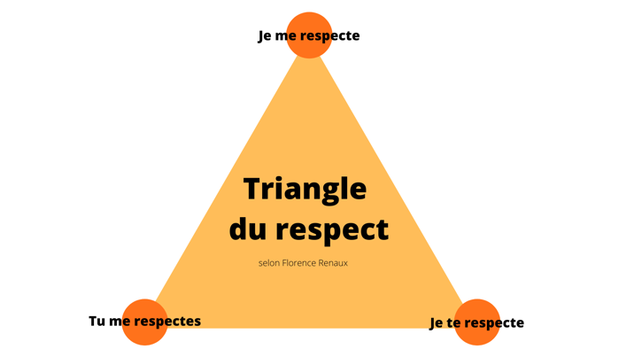

A respectful student avoids any act that may violate the dignity of the person.

5. Punctuality

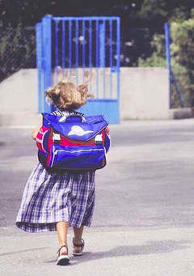
Synonymous with regularity, punctuality will help the student to be on time to learn well.

As time is money, on the way to school, a punctual student avoids anything that might distract him or her and prevent him or her from arriving on time.

Late arrivals at school block the student. While the others learn, the one who is late loses. Latecomers are always wrong, it is often said.

Punctuality leads the student to be disciplined and orderly. In this way, discipline and order encourage the student to sleep and get up early, to prepare everything the night before: his homework, his uniform, his classic objects, etc.

6. Honesty

An honest student tells the truth and deserves his success. He is frank, avoids corruption and cheating.

Intellectual honesty urges an honest student not to plagiarize: to use a quote or phrase that is not his own, without quoting the name of its author.

Honesty must also lead the student to confess what he or she has done. (Ps 32:5) If he or she were to commit a wrongdoing, he or she would have to do a mea culpa, confess, and ask for forgiveness.

God wants men to be honest in all things; that is, to conduct themselves uprightly in all things. (Heb 13:18) God wants men to be honest in all things.

7. Determination

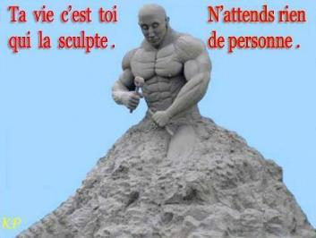
Determination is not without a spirit of sacrifice. A good student must have a sense of sacrifice in everything he undertakes: going to school every day (sometimes on foot or hungry), reading his notes (sometimes with a kerosene lamp...), doing his homework, etc. require a certain amount of self-sacrifice.

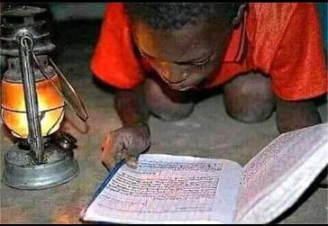

Thanks to his determination to want to succeed, a good student gets to the end, notwithstanding the pitfalls he may encounter along the way.

The determination the ant has can serve as an example to a good student. Having no leader, inspector, or master, the ant works and fights "beak and uncle" for its survival (Prov 6:6-8).
8. The application

The work of the student can be compared to that of the farmer: " . . what a man sows, he will also reap. What a man sows, he will also reap. (2 Corinthians 9:6) If you sow much, you will reap much.
There is no doubt that student achievement is dependent on the student's efforts to learn lessons and to participate actively in the classroom.

A studious student reviews his

notes every day. A saying that says, "He who hugs too much, hugs wrong", can serve as a lesson for students who accumulate a lot of material without reviewing it. They will not be able to understand them all on the eve of a test.

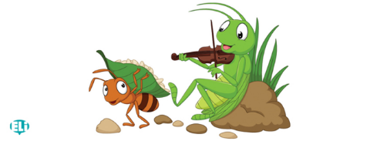
Here again, the ant serves as an example. The story "The Cicada and the Ant", a fable by Jean de La Fontaine (1621-1695), teaches us that idleness is a vice, and that it is only through work that man achieves independence, well-being and success.

9. Emulation

It's the desire to want to be equal to or better than the other. R. Musomo (2014) sees emulation as a powerful stimulus that excites students to do three things: work hard, imitate the best, and try to surpass them.

Far from being considered as a feeling of envy, emulation pushes a good student to avoid mediocrity and to always aim for excellence.

Following the example of Simon Peter, who once gave a satisfactory answer to his Master Jesus: "You are the Christ, the Son of the living God" (Mt 16:13-17), so it must be for a good student. His answers should please his teacher and help the class understand. Lack of emulation in a student's school life can cause him to fall into intellectual lethargy.

10. Self-help
This must be reciprocal, especially since no one can be gifted in everything, nor can one live or work in isolation indefinitely. One will always need the other.

Mutual aid is an unfailing sign that you love your alter ego, your brother, and that you want what's best for you.
The talents we have are gifts that come from God. They do not belong to us alone. We must make them fruitful and put them at the service of our brothers and sisters (Mt 25:14-29; 1 Pet 4:10). A gifted student who does nothing for his fellow student will have failed in the duty of charity to which God invites us. Just as in Cain, God will ask him: "What have you done with your brother? "(Gen 4:10).

Seen as a beautiful demonstration of the adage (Belgium's motto) according to which "unity makes strength", mutual aid will consolidate efforts to succeed in the classroom.

11. Humility

Humility is not a weakness, but rather a strength. It helps us to know that we have to give and receive from others.
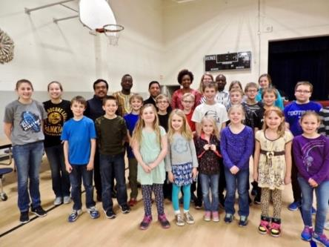
If humility precedes glory, the Holy Scriptures also tell us (Pr 15:33), pride, on the other hand, precedes failure and fall, for the heart of man rises before ruin (Pr 18:12).

Through humility, a good student will maintain good relations with his fellow students.

He will also know how to follow his master's instructions by allowing himself to be molded by him, just as clay is molded in the hands of a potter (Rom 9:21; Isa 64:8).

12. Recognition

The gratitude of a good student must be shown to God, to his parents, and to his educators.

To God because he is the author and source of all wisdom and understanding (Jb 12:13; Jc 1:5).

To his parents for all the efforts and sacrifices they have made for his education and training. Finally, to his educators for their love and devotion.

Following the example of the only leper who went back to give thanks to the Lord (Lk 17:15-16), a good student must be grateful to God, his parents, and his teachers.
Conclusion

We conclude by saying that it is good for a student to be virtuous. A virtuous student builds a bright future for himself or herself, a future that will allow him or her to realize his or her deepest dreams.

The twelve virtues of a good student, which we have studied in this booklet, promote a child's success in all aspects of life.

I, ...…………………………………… I'm a student and I want to succeed in life. I commit myself to be good and virtuous. I'll fight the anti-values. I realize that my future will depend on what I do with my present. I will follow carefully and I will put into practice everything that my parents and teachers will recommend to me. I will flee from evil companions and live in the fear of the Lord.

Dear parents and teachers, help me to be virtuous. Count on me, I won't disappoint you.
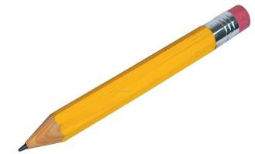

* Signum Fidei: Sign of Fa ith
Excerpt from The Twelve Virtues of a Good Student and a Good Parent in the Development of Education and Instruction (Parents' Handbook)

Appendix 1
A few souvenir texts
1. The Good Schoolboy

It's time to get to class. Little Manza greets his mother affectionately and leaves in a light-hearted step. Arrived in
class, he makes the sign of the cross, greets the teacher, and goes to the
his place. During prayers, he has a respectful posture.
He listens attentively to the lessons and answers questions politely, always diligent and silent, Manza brings joy to the students.
of his master. When class is over, he goes straight home.
2. The docile child
(Little Mata goes to class)
"Goodbye! Little darling, you're going to class:
Don't get punished.
- No mom ! What do I have to do for that ?
- Only one thing, obey.
I'll obey Mummy". He keeps his word so well,
That since then we've enjoyed
Seeing him all happy to be leaving for his school,
And, all happy, come back from it.
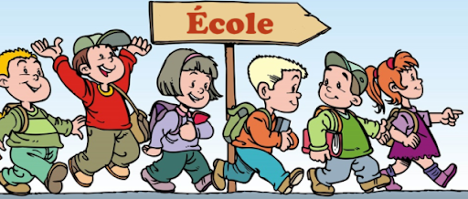

3. The clean child

When they say:
"Whose beautiful child is this:
This Christmas so sweet, so clean. "
It's all so proud
That the mother
Will respond
"This beautiful child is mine."

- Advice from a bee
Schoolboy, who's leaving for school  Just don't drag your feet;  On the way don't have fun  But think of the time that flies.  For your model and your symbol.  If you believe me, you will choose;  Not the frivolous butterfly.  Too much of a friend to joyous frolicking | But the bee's always in a hurry,  Who forage in the dew  All flowers rich in honey  Never play hooky,  Says the good counselor,  Flying between earth and sky.  H. Durand

*Elementary Reading 2 (Pp. 61, 78 & 80)
Appendix 2
Canticle to Saint John Baptist de La Salle
A / Honour to you, Glorious de La Salle
Apostle to the children and guardian of their faith;
Winner of ignorance, has such a fatal blade,
Honour to you! Honour to you!

1. O you, the chosen ones like us, applaud
And sing, triumphing in the courts of heaven,
To exalt your glory, here our eyes unite...
With transport to the eternal hymn.

2. You were the companion of the angelic spirits,
Who keep the young age, still in its flower,
And always see the eternal porticoes shining brightly
Where from God himself appears splendour.

3. 3. The people of the children's children as a boss are asking for you;
The masters have appointed you their guide and doctor...
And all of them, in invoking you, hope for their souls...
Rescue and strength, O mighty Protector!
